**Module 08 Assignment**

1. Draw an ERD to track lab tests performed by a medical laboratory on clients. The database should track basic client details including a unique client identifier,client name, client insurance provider (if any), client address, client date of birth, and client sex. The database should track the unique identifier for a lab test, the test type identifier, the date and time when the lab test was administered, and the identifier of the lab employee performing the test. A client can request multiple tests in a visit to the lab. The database only contains clients who have had lab tests performed. Each lab test is administered to one client.

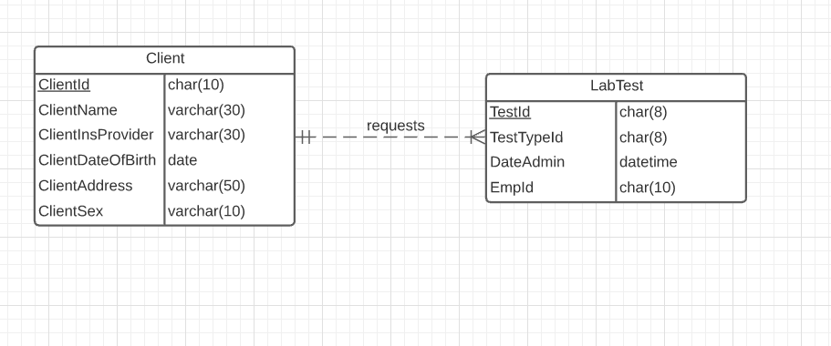

2. Revise the ERD from problem 1 with more details about test types. A test type includes a unique test type identifier, a test type name, a test type cost, and a test type code. A lab test administered to a client is associated with one test type. A test type can be administered to multiple clients. A test type can exist in the database without ever being administered.

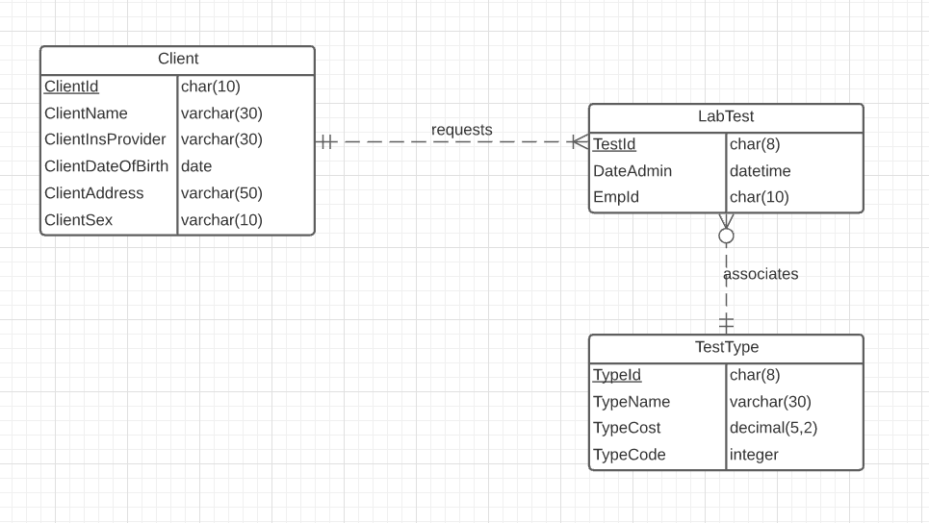

3. Revise the ERD from problem 2 with test type items. A test type item includes a unique test item identifier, a test item name, test item unit of measure, and a test item description. A test type includes one or more test items. A test item can be part of one or more test types. Do not use an M-N relationship.

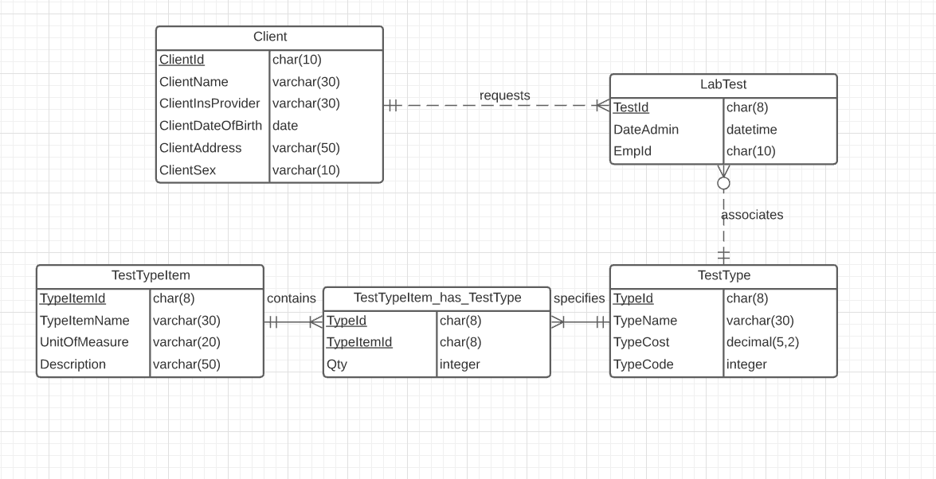

4. Revise the ERD from problem 3 to use an M-N relationship.

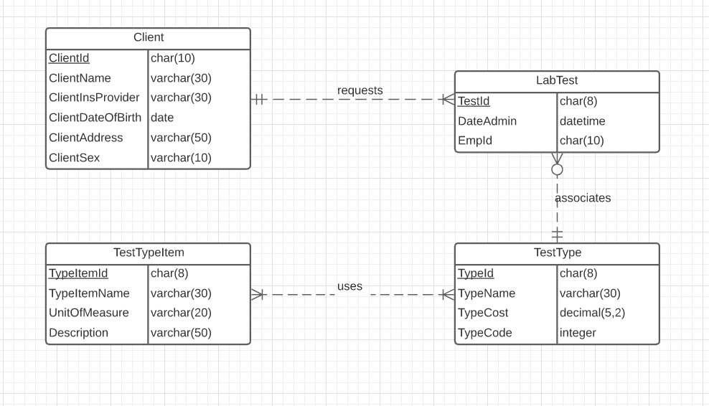

**Module 09 Assignment**

1. For the following problem, define an ERD for the initial requirements and then revise the ERD for the new requirements. Your solution should have an initial ERD, a revised ERD, and a list of design decisions for each ERD. In performing your analysis, you may want to follow the approach presented in module 9.

Design a database for managing the task assignments on a work order. A work order records the set of tasks requested by a customer at a specified location.

* A customer has a unique customer identifier, a name, a billing address (street, city, state, and zip), and a collection of submitted work orders.
* A work order has a unique work order number, a creation date, a date required, a completion date, a customer, an optional supervising employee, a work address (street, city, state, zip), and a set of tasks.
* Each task has a unique task identifier, a task name, an hourly rate, and estimated hours. Tasks are standardized across work orders so that the same task can be performed on many work orders.
* Each task on a work order has a status (not started, in progress, or completed), actual hours, and a completion date. The completion date is not entered until the status changes to complete.

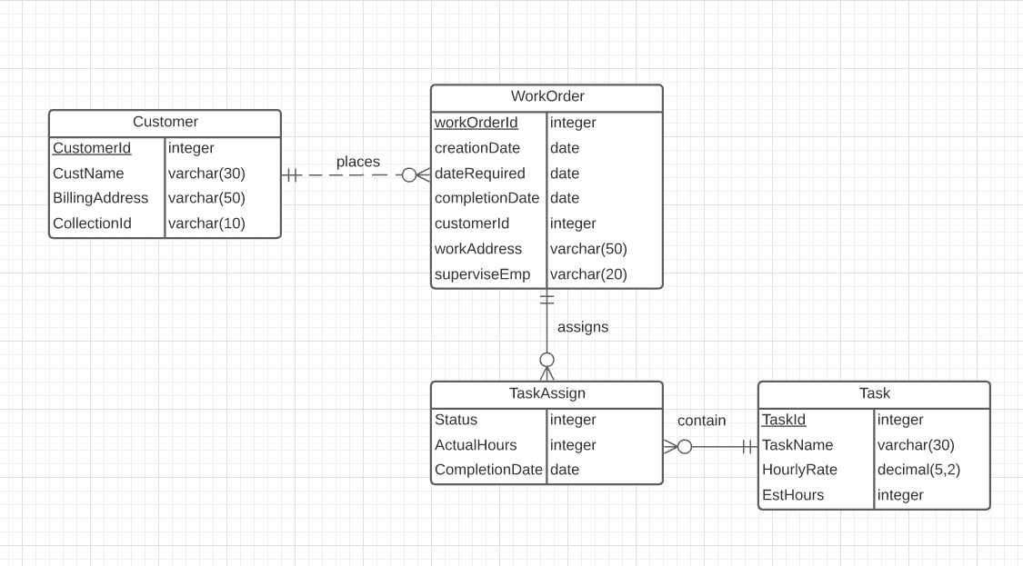

After reviewing your initial design, the company decides to revise the requirements. Make a separate ERD to show your refinements. Refine your original ERD to support the following new requirements:

* The company wants to maintain a list of materials. The data about materials include a unique material identifier, a name, and an estimated cost. A material can appear on multiple work orders.
* Each work order uses a collection of materials. A material used on a work order includes the estimated quantity of the material and the actual quantity of the material used.
* The estimated number of hours for a task depends on the work order and task, not on the task alone. Each task of a work order includes an estimated number of hours.

